MIN-Franklin-NJ- Pectolite and Prehnite on Matrix

Name:  Pectolite and Prehnite on Matrix  
Weight: approximately 1130 carats  
Dimensions:  approximately 4" x 1.5" x 3"  
Location:  Lower New Street Quarry, Paterson, New Jersey  
Additional Minerals:  Unknown

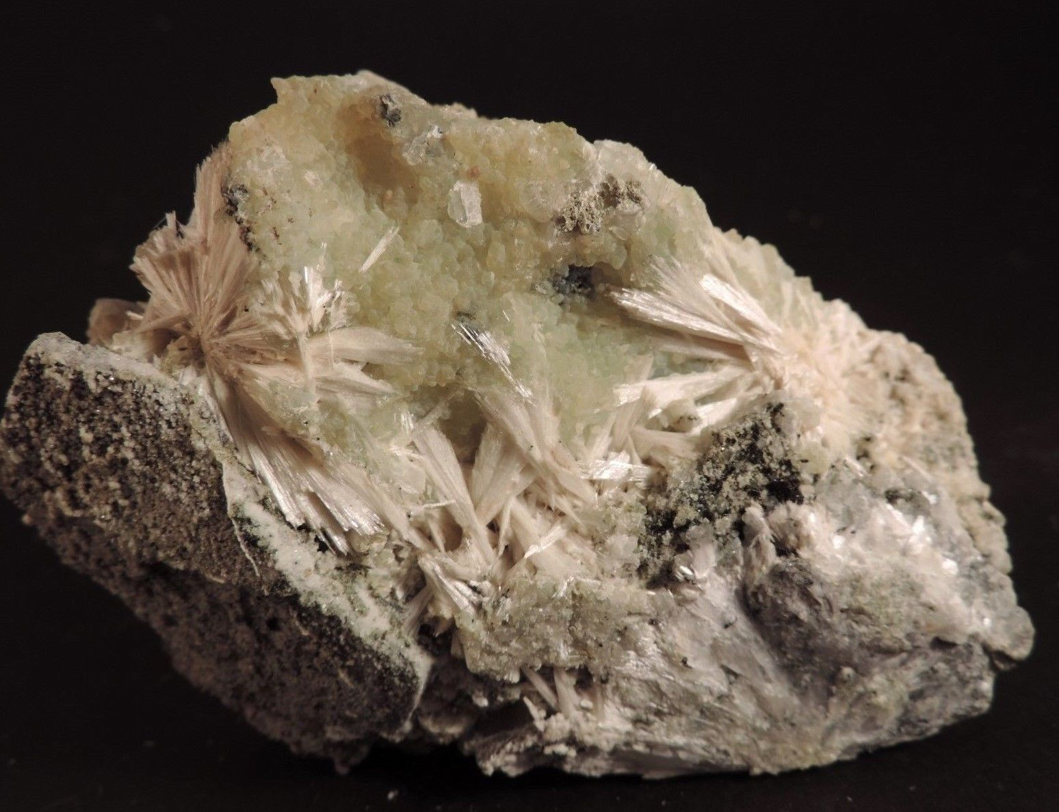

# 

# Order details

← Back to order details

|  |  |  |  |  |  |  |  |  |  |  |  |  |  |  |
| --- | --- | --- | --- | --- | --- | --- | --- | --- | --- | --- | --- | --- | --- | --- |
| Order information  |  |  | | --- | --- | | **Order placed on** | Monday, Jul 4, 2016 | | **Payment method** | PayPal | | **Payment date** | Monday, Jul 4, 2016 | | Shipping address Ralph J Coffman Jr  149 Atlantic Ave  Swampscott MA 01907-2427  United States | Order total  |  |  | | --- | --- | | **Subtotal** | $34.99 | | **Shipping** | Free | | **Total** | $34.99 | |
|  |  |  |
| Item(s) bought from**7_continents_minerals_and_mining**    | **Qty** | **Item name** | **Shipping service** | **Item price** | | --- | --- | --- | --- | | 1 | Pectolite and Prehnite Mineral Specimen, New Jersey - Museum Quality! (162109257948) | USPS First Class Package | $34.99 | | | |